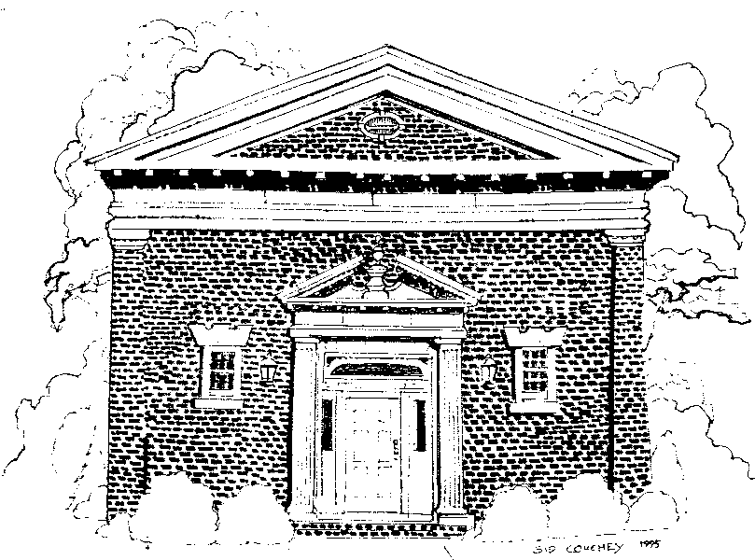

PAINE MEMORIAL FREE LIBRARY 2025-2026 STORY HOUR REGISTRATION FORM
FOR CHILDREN AGES 3-5
September 12^{th _} June 12th Friday Mornings: 10:00 am -11:00 am
The Story Hour Program Follows the Willsboro Central School District Calendar

Child’s Name ___________________________________________ DOB ______________________________________
Parent’s/Guardian’s Name(s) _____________________________________________________________________
Address _____________________________________________________________________________________________
Telephone # (day) ___________________________________ (evening) __________________________________
Email Address ______________________________________________________________________________________
Emergency Contact Name ___________________________________ Tel. _________________________________
Please provide any information about your child that you would like to share or believe we should be aware of. For example, learning style, behavior, likes, dislikes, fears, health issues, allergies.
____________________________________________________________________________________________________________________________________________________________________________________________________________________________________
What type of books/topics interest your child? __________________________________________________________________________________________________________________

What type of interactive games/songs/music/imaginary play/crafts does your child like?
_________________________________________________________________________________________________________________

Are there any skills that you feel are a high priority for your child to work on? (ex: taking turns, playing with others, fine motor skills, attention, listening, etc.)
________________________________________________________________________________________________________________

